UNIVERSITY OF WAH (UOW)

DEPARTMENT OF COMPUTER SCIENCE



COURSE TITLE: ARTIFICIAL INTELLIGENCE

COURSE CODE: CS – 202 L

SUBMITTED TO: SIR HASSAN SHAFAQAT

SUBMITTED BY: SAADI SAFDAR

REG #: UW-24-CS-BS-088

BSCS 3RD B

LAB TASK # 11

Implementation using A* Algorithm (Class Task):

import heapq

graph = {
'A': [('B', 1), ('C', 5)],
'B': [('D', 7)],
'C': [('E', 8)],
'D': [('E', 10)],
'E': []
}

heuristics = {
'A': 8,
'B': 7,
'C': 5,
'D': 3,
'E': 0
}

def a_star_algorithm(graph, heuristics, start, goal):
open_list = []
heapq.heappush(open_list, (heuristics[start], 0, start, [start]))

while open_list:
f, g, current, path = heapq.heappop(open_list)

if current == goal:
return path, g

for neighbor, cost in graph[current]:
new_g = g + cost
new_f = new_g + heuristics[neighbor]
heapq.heappush(open_list, (new_f, new_g, neighbor, path + [neighbor]))

return None, float('inf')

path, cost = a_star_algorithm(graph, heuristics, 'A', 'E')

print("Optimal Path:", path)
print("Total Cost:", cost)

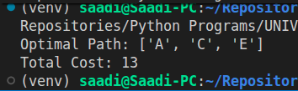

Lab Task:
You are working with a warehouse robot that must plan the shortest path from the entry
gate to the delivery zone. Design your own city/warehouse map using a graph, assign
heuristic values, and use A* to calculate the most efficient route. Your graph should have at
least 6 nodes and contain multiple possible paths. Display the final path and total cost.

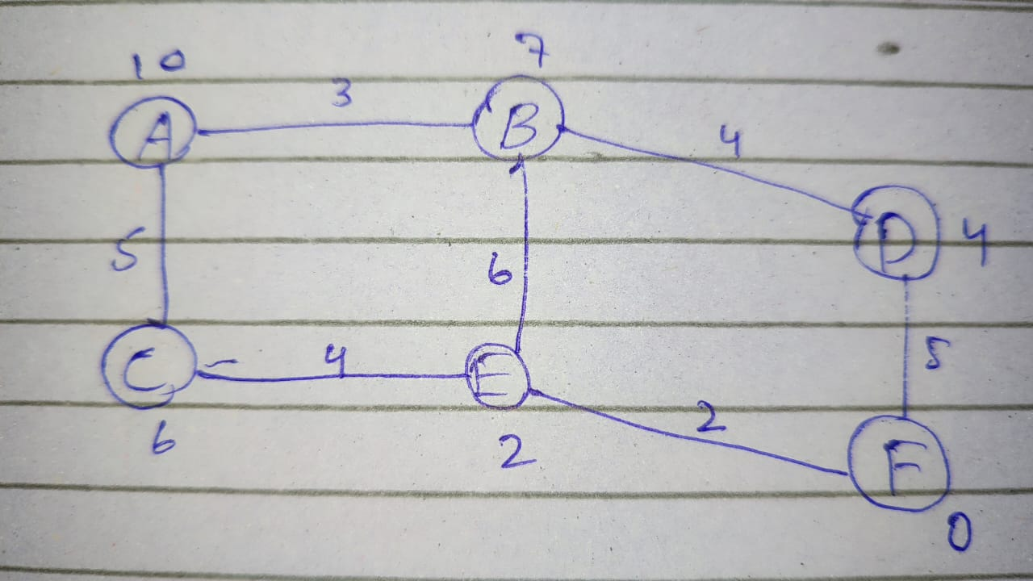

import heapq

warehouse_map = {
'A': [('B', 3), ('C', 5)],
'B': [('D', 4), ('E', 6)],
'C': [('E', 4)],
'D': [('F', 5)],
'E': [('F', 2)],
'F': []
}

heuristics = {
'A': 10,
'B': 7,
'C': 6,
'D': 4,
'E': 2,
'F': 0
}

def warehouse_robot_path(graph, heuristics, start, goal):

open_list = []
heapq.heappush(open_list, (heuristics[start], 0, start, [start]))
visited = {}

while open_list:
f, g, current, path = heapq.heappop(open_list)

if current == goal:
return path, g

if current in visited and visited[current] <= g:
continue
visited[current] = g

for neighbor, cost in graph[current]:
new_g = g + cost
new_f = new_g + heuristics[neighbor]
heapq.heappush(open_list, (new_f, new_g, neighbor, path + [neighbor]))

return None, float('inf')

path, total_cost = warehouse_robot_path(warehouse_map, heuristics, 'A', 'F')

print(f"Optimal Path: {' -> '.join(path)}")
print(f"Total Distance: {total_cost} meters")

